Problem Set 9 – One-Way ANOVA

Problem 1 (35 points)
Please access the Missouri Housing Survey dataset, which was pulled from a much larger study. It contains 30,531 observations (from an original 720,248), on 231 variables. For a description of the variables, please access the PUMSDataDict13 data dictionary which you will need. This problem has been designed to provide a purposely sanitized, but still excellent opportunity to perform an ANOVA under realistic circumstances.

Please answer each of the following questions. So that your answers remain focused, you are to include ONLY the item(s) requested (else, your earned credit will be reduced). Do not do any imputation of missing values and do not remove any observations unless directed to do so.

You are interested in whether Family Income (past 12 months) differs across Household Language, as categorized by the study. Although there is no “experimental design” here, one may assume this study can be analyzed just as any one-way ANOVA would be, with the treatment being “Household Language” and the response being Family Income (past 12 months).

Data Recoding: Use JMP to recode the Household Language column to replace the numbers with the phrases or parts of the phrases from the codebook.

- (4 points) Cut and paste ten lines of the recoded dataset here so that there is proof that it was done correctly. Hint: right click on the HHL column and choose recode. Make sure you are using HHL. There are lots of variables that look alike.

HHL HHT HINCP
English 5 37100
N/A
English 1 76000
English 1 119850
English 6 7850
N/A
N/A
English 1 115900
English 1 72350
English 1 48000
Generating the ANOVA Output: Use the recoded Household Language variable to test the hypothesis of H0: “there is no difference across Household Language categories with respect to Family Income (past 12 months).” Make sure you are using Family Income (past 12 months). There are lots of variables that look alike. Use Fit Y by X.

- (3 points) Copy and paste the Analysis of Variance table (Fit Y by X) here.

Source | DF | Sum of Squares | Mean Square | F Ratio | Prob > F
HHL 2 | 4 | 2.1757e+11 | 5.439e+10 | 11.3700 | <.0001*
Error | 16297 | 7.7964e+13 | 4.7839e+9
C. Total | 16301 | 7.8181e+13

- (5 points) Copy and paste a plot of the data here. Plot by Household Language, with all the mean lines displayed on the data, but not the default diamonds. Change the y-scale so that the maximum income displayed is $200,000 or below (but not below 0), and make sure the values on the horizontal axis are equally spaced.

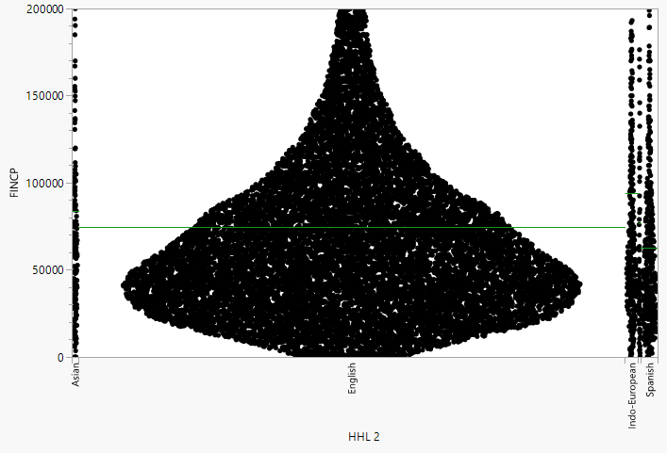

- (3 points) In one sentence, and just by looking at the plot, indicate which Household Language has a mean Family Income that is right at the grand mean?

The English household language category has a mean family income approximately equal to the grand mean.

- (3 points) In one sentence, and just by looking at the plot, indicate which pair of means appear to be most likely to be different.

The Indo-European and Spanish household language categories appear to have the greatest difference in mean family income.

- (5 points) Revisit the Analysis of Variance table in part b. Did you reject the null or not? Explain in words what that means in the context of this problem.

We reject the null hypothesis because the p-value (< 0.0001) is less than the significance level of 0.05. This indicates that there is a statistically significant difference in mean family income among household language categories, meaning at least one household language group has a different mean family income.

- (3 points) Copy and paste the Ordered Difference Report table in the space below. This table records all the unadjusted pairwise confidence intervals (see slide 40).

Level | - Level | Difference | Std Err Dif | Lower CL | Upper CL | p-Value
Indo-European | Spanish | 31126.32 | 4818.465 | 21681.6 | 40571.04 | <.0001*
Asian | Spanish | 21191.90 | 6012.251 | 9407.2 | 32976.57 | 0.0004*
Indo-European | English | 19115.86 | 3639.254 | 11982.5 | 26249.20 | <.0001*
Indo-European | Other | 16849.86 | 8710.690 | -224.0 | 33923.77 | 0.0531
Other | Spanish | 14276.46 | 8557.721 | -2497.6 | 31050.53 | 0.0953
English | Spanish | 12010.45 | 3256.171 | 5628.0 | 18392.90 | 0.0002*
Indo-European | Asian | 9934.42 | 6228.056 | -2273.3 | 22142.09 | 0.1107
Asian | English | 9181.44 | 5116.027 | -846.5 | 19209.42 | 0.0727
Asian | Other | 6915.44 | 9423.676 | -11556.0 | 25386.88 | 0.4631
Other | English | 2266.00 | 7953.688 | -13324.1 | 17856.10 | 0.7757

- (5 points) Refer to part g. Suppose we want to take α = 0.05 as an overall (experiment-wise) error rate and do Bonferroni comparisons of the pairs of means in that table shown in part g. What value of α would you need to use while making those comparisons?

Use a significance level of α = 0.005 for each pairwise comparison to maintain an overall experiment-wise error rate of 0.05.

- (4 points) Take α = 0.05 as an overall (experiment-wise) error rate. Implement the Tukey HSD multiple comparison procedure using JMP. Exhibit the Connecting Letters Report below and in 100 words or less, identify which pairs of means are statistically different.

The Tukey HSD test identified four statistically significant differences in mean family income at α = 0.05. These differences occurred between Indo-European and English, Indo-European and Spanish, Asian and Spanish, and English and Spanish households. All other household language comparisons were not statistically significant because they shared at least one letter in the Connecting Letters Report.

Problem 2 (15 points)
Please access the Purdue Reading dataset which will be linked on Canvas. This dataset is the same as was discussed in the slides (33-49) and used to introduce and illustrate mutiple comparisons. You are interested in whether whether Post1MinusPre1 (see slides) differs between the Basal and Drta reading methods. You are not interested in the Strat method for this problem so do NOT include it in your work. The connection between ANOVA models and regression was introduced in the content on slides 25-29. We are going to revisit that connection very superficially here.

Please answer each of the following questions. So that your answers remain focused, you are to include ONLY the item(s) requested (else, your earned credit will be reduced).

- (5 points) Use Fit Y by X to do a usual ANOVA for these data. Copy and paste the Analysis of Variance table in the space below.

Source | DF | Sum of Squares | Mean Square | F Ratio | Prob > F
method | 1 | 131.27273 | 131.273 | 17.5385 | 0.0001*
Error | 42 | 314.36364 | 7.485
C. Total | 43 | 445.63636

- (5 points) Refer to part a. There is one F test exhibited in the Analysis of Variance table. Identify the hypothesis being tested there. Only one of the possible answers shown below is reasonable. Place an “X” in the box to the immediate left of your chosen answer.

Problem 2b: Solution Choices
 | H₀:μ_{basal} = μ_{drta} = 0, where the μ’s refer to the population means across the variable Post1MinusPre1
 | H₀: Method = 0, where Method takes on two values, basal and drta.
 | H₀:μ_{basal} = μ_{drta}, where μ_{basal} refers to the population mean across the variable Post1, and μ_{drta} refers to the population mean across the variable Post1
x | H₀:μ_{basal} = μ_{drta}, where the μ’s refer to the population means across the variable Post1MinusPre1

Key to understanding what ANOVA-specific routines were really doing rested in the knowledge that they were just regression routines in disguise. The content videos loosely established the connection by identifying the One-Way ANOVA model with the following:

Regression model: Post1MinusPre1 = μ_{basal}X_{basal} + μ_{drta}X_{drta} + ε.

- (5 points) Refer to the regression model in the paragraph above. Identify the form of the regressor variable X_{basal}. Only one of the possible answers shown below is reasonable. Place an “X” in the box to the immediate left of your chosen answer.

Problem 2c: Solution Choices
 | X_{basal} is a data column with all 1’s corresponding to responses to the the difference in drta and basal treatment values, and 0’s otherwise.
x | X_{basal} is a data column with all 1’s corresponding to responses to the basal treatment, and 0’s otherwise.
 | X_{basal} is a data column with all 1’s.
 | X_{basal} is a data column all the Post1MinusPre1 values for the basal treatment

Addendum: To think about. The only hypotheses you have learned about on a regression output are the overall F test (β₁=β₂= … = β_{k} = 0) and the individual F/t tests (β_{j} = 0). Neither of these correspond to the test you’d need to perform to repeat the ANOVA F test on regression output. Rather, you’d need to construct another type of test using options in the software.

Remember: It makes no sense to try and interpret parameter estimates in an ANOVA context. Indeed, ANOVA is just regression, but computer output for ANOVA models focuses on the Analysis of Variance table, not the Parameter Estimates table.

